Motion # 25.219/2

JAMHUURIYADDA SOMALILAND GOLAHA WAKIILLADA
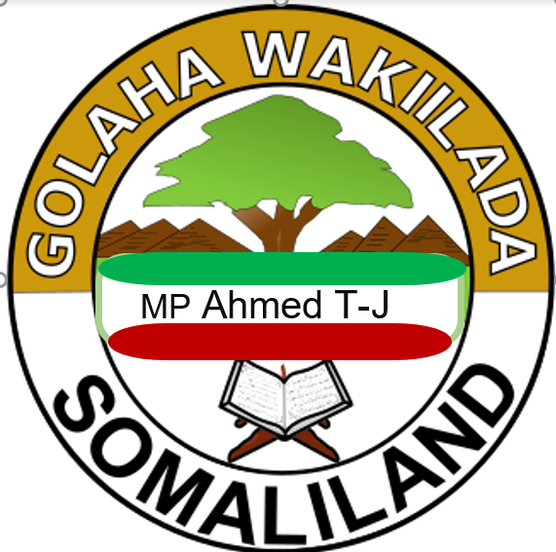
To: His Excellency António Guterres
Secretary-General
United Nations Headquarters
New York, NY 10017 United States
Cc: Director, Treaty Section, Office of Legal Affairs, United Nations
Subject: Formal Request for Admission of the Republic of Somaliland to the United Nations
Integrated Legal Annex – Evidence Of State Continuity Of The Republic Of Somaliland

Annex I: Evidence of International Legal Personality and State Continuity of the Republic of Somaliland

1. Purpose and Scope
This Annex is submitted in support of the Republic of Somaliland’s request for consideration of admission to the United Nations pursuant to Article 4 of the UN Charter. It consolidates and aligns the legal, historical, and documentary evidence demonstrating Somaliland’s international legal personality attained on 26 June 1960, and the uninterrupted continuity of that statehood notwithstanding the subsequent unratified and unlawful union purportedly effected on 1 July 1960.

2. Identity and Continuity of Somaliland
The present-day Republic of Somaliland is the same legal entity that achieved independence from the United Kingdom of Great Britain and Northern Ireland on 26 June 1960. The designation “Republic” has been used since 1991, following the restoration of sovereignty after Somaliland expelled the illegal occupying authority of Somalia. This change in designation does not affect the continuity of the State’s legal personality.
Somaliland’s claim is therefore one of state continuity and restoration of sovereignty, not secession.

3. Treaty-Making Capacity and UN Registration (Article 102)
Somaliland’s sovereignty and treaty-making capacity in 1960 are evidenced by international agreements concluded in its own name and registered in the United Nations Treaty Series (UNTS) in accordance with Article 102 of the UN Charter. Such registration is prima facie confirmation that Somaliland was treated as a subject of international law capable of entering treaty relations.

3.1 Treaties Registered in the UN Treaty Series
The following instruments were concluded between the United Kingdom and Somaliland, entered into force on 26 June 1960, and registered with the United Nations on 13 September 1960:
- UNTS No. 5346 — Interim Agreement for a United Kingdom Aid Mission (Signed at Hargeisa, 26 June 1960; entered into force by signature pursuant to Article VIII).
- UNTS No. 5347 — Public Officers Agreement (Signed at Hargeisa, 26 June 1960; entered into force by signature pursuant to Article VII).
- UNTS No. 5348 — Agreement Regarding Interim Arrangements in Respect of the Somaliland Scouts (Signed at Hargeisa, 26 June 1960; entered into force by signature pursuant to Article X).
- UNTS No. 5349 — Exchange of Letters Concerning the Transfer of Obligations in the Event of Jurisdictional Transfer (Signed at Hargeisa, 26 June 1960; entered into force by exchange of letters).
- UNTS No. 5350 — Exchange of Letters Concerning the Continued Availability of East African Currency Board Currency (Signed at Hargeisa, 26 June 1960).
These registrations confirm that Somaliland possessed international legal personality at independence.

4. Absence of a Valid Instrument of Union
No lawful international treaty exists by which Somaliland relinquished or extinguished its sovereignty after 26 June 1960. The purported union of 1 July 1960 fails to meet basic requirements of treaty law because:
- It was never ratified by Somaliland’s legislature;
- It was not concluded as a single, harmonized treaty between two sovereign states;
- It was never registered with the United Nations under Article 102 of the UN Charter;
- It lacked constitutional validity within Somaliland.
Accordingly, the purported union does not constitute a binding international instrument.

5. Applicable Principles of International Law
Somaliland’s legal position is supported by established principles, including:
- Self-Determination (UN Charter, Article 1(2));
- Admission of Peace-Loving States (UN Charter, Article 4);
- State Continuity Doctrine, as reflected in international practice and jurisprudence;
- Montevideo Convention (1933) criteria, all of which Somaliland satisfies: defined territory, permanent population, effective government, and capacity to enter into relations with other states.

6. Consequence for UN Consideration
Because Somaliland’s sovereignty was lawfully established in 1960 and never lawfully extinguished, the current request before the United Nations concerns the recognition and admission of an existing state, correcting a historical and institutional misattribution.

7. Concluding Legal Position
Recommended formulation for UN records:
“The Republic of Somaliland is the continuing legal personality of the State of Somaliland that attained independence on 26 June 1960, as evidenced by treaties concluded in its own name and registered in the United Nations Treaty Series. No lawful international instrument exists by which that sovereignty was transferred or extinguished.”
Submitted on behalf of the Government and People of the Republic of Somaliland.

MOOSHIN KU SOCDA GOLAHA WAKIILADA JSL
04/01/2024
ku: Xogahayaha guud ee golaha wakiilada jsl.
OG: shirguddoonka/Guddoomiyaha Golaha Wakilada JSL
Hordhac
Mr. Xoghaye waxaanu si sharaf iyo karaamo Ku dheehanthaay ugu soo gudbinaynaa Golaha wakiilada JSL Mooshin Sharci oo nuxurkiisu yahay difaaca qaranimada Somaliland oo waajib Ku ah golahan iyo muwaadinkasta reer Somaliland wiil iyo gabadhba inuu difaaco qaranimadiis qawl iyo ficilba Golahan waxaanu ka codsanaynaa inuu resolution Ku meel mariyo kajawaabida Xoghayaha qaramadA MIDOOBAY EE suaashan shaRCI ee cad ee Ku socota UNta
Mooshinka

Waxanu Hambalyaynaynaa sanadguurada 80aad ee QM.
Mudane Guddoomiye iyo Mudanayaal sida Ku xusan Dastuurka JSL iyo xeerhoosaadka golaha qodobadiisa 42aad ee XHG, farq,1aad, 2aad, 3aad,4aad, iyo 5aad isla markaana sida Ku xusan qodobka 43aad ee XHG mooshinkani waa mid ka baxsan xil gudashada baarlamaanka u gaarka ah oo ah mid qarran (Substantive Motions). Mooshinkaas aayaanu anaga oo ah xildhibaanada kusaxexan halkan ugu soo gudbinaynaa Golaha wakiilada JSL. Mooshinkan Sharci oo nuxurkiisu yahay difaaca qaranimada Somaliland oo waajib Ku ah golahan iyo muwaadinkasta oo reer Somaliland ah wiil iyo gabadhba, sida ku cada qodobka 10 aad ee dastuurka jsl farqadiisa 4aad. 5 aad 6aad 7 aad.
Nuxurka Mooshinka
Annaga oo ah golaha wakiilada JSL waxanoo muuqata in QM tirtiray qarankan xuquuqdiisii xuquuqdooda si joogto ah loogu xadgudbay qarankan iyo dadkiisaba. Qaladaad habraaceed oo ay samaysay Qaramada Midoobay waxay Somaliland, oo ah waddan la aqoonsaday kadib 26-kii June 1960-kii, ka dhigtay dal la’aan. Madagaskar (oo hore u ahaan jirtay Malagasy) oo ah dawlad xornimadeeda qaadatay isla maalintii ay Somaliland qaadatay, waxa ay ku jirtaa liiska Qaramada Midoobay. Somaliland kumajirto.
Warqadani waa ogaysiis rasmi ah oo cabasho ah oo ku socota Xoghayaha qaramada midobey iyadoo ku saabsan iska dhigista Dawladda Soomaaliya ee Somaliland
Jamhuuriyadda hadda jirta ee Somaliland waa isla dalkii ka madax banaanaadey Boqortooyada Midowday 26-kii Juun 1960, qalabkaasna lagu diiwaan geliyey Taxanaha Heshiisyada Qaramada Midoobay. marlabad Somaliland waxay dib u xaqiijisay madax-bannaanideedas hore . GUmaysiga Madoobi wuxu kumanaan jeer ka xunyahay gumaystihii reer yurub. awoodna u yeelatay inay kasaarto ciidamadii xooga Ku qabsadey ee somaliya,
Qarankan qalabkiisa waxa lagu diiwaan geliyey Taxanaha Heshiisyada Qaramada Midoobay. Qalabkaas sida Ku cad qodobadan Ku xardhan taxanaha diwanka QM: -
No. 5346 BOQORTOYOADA MIDOWDAY EE GREAT BRITAIN IYO WAQOOYI IRELAND IYO SOMALILAND: Heshiis ku meel gaadh ah oo ku saabsan howlgalkii caawimada ee Boqortooyada Midowday. Waxaa lagu saxiixay Hargeysa, Somaliland, 26/06/1960. Waxaanu dhaqan galay 26 Juun 1960 markii la saxiixay, iyadoo laysku waafaqsan yahay sida kucad Qodobka VIII. Waxaa diiwaan geliyey Boqortooyada Midowday ee Great Britain iyo Waqooyi Ireland 13 Sebtembar 1960.
NO. 5347 BOQORTOOYADA INGIRIISKA IYO WAQOOYIGA IRELAND IYO
SOMALILAND: Heshiiska Saraakiisha Dawladda. Waxaa lagu saxiixay Hargeysa, Somaliland, 26/06/1960. waxa la saxiixay uu dhaqan galay 26 Juun 1960 , iyadoo la raacayo Qodobka VII. isKana Diiwaangalisay Boqortooyada Ingiriisku iyo Waqooyiga Ireland 13 Sebtember 1960. To the UN treaties.
• No. 5348 BOQORTOOYADA INGIRIISKA IYO WAQOOYIGA IRELAND IYO
SOMALILAND: Heshiis ku saabsan qabanqaabada ku-meel-gaarka ah ee ku saabsan Scouts Somaliland Waxaa lagu saxiixay Hargeysa 26 Juun 1960. 26-kii Juun 1960-kii ayaa la soo gabagabeeyay Koobka Adduunka, waxaana la filayaa in Next article Dowlada Ingiriiska Oo Ka Hadashay Qaraxii Shalay Ka Dhacay Muqdisho Iyo Khasaaraha Ka Dhashay
Ireland 13 Sebtember 1960.

• No. 5349 BOQORTAHA MIDOWDAY EE GREAT BRITAIN IYO WADANKA WAQOOYI IRELAND IYO SOMALILAND: Is-weydaarsi warqado ah oo sameynaya heshiis sheegaya in, haddii Dowladda Somaliland ay ka mid noqoto heshiis kasta oo Ku wareejinaya maamulka dhulka Somaliland dowladda kale, heshiiskaas uu qeexayo in waajibaadka Dowladda Somaliland ee ku saabsan qalabka qaarkood loo wareejinayo dowladdaas kale. Lagu saxiixay Hargeysa, 26 Juun 1960. Waxay dhaqan gashay 26 Juun 1960 iyada oo la is-weydaarsaday warqadaha la is-gaadhsiiyey. Waxaa diiwaan geliyey Boqortooyada Midowday ee Great Britain iyo Waqooyiga Ireland 13 Sebtembar 1960.
• No. 5350 BOQORTooyada MIDOWDAY EE GREAT BRITAIN IYO WAQOOYI IRELAND IYO SOMALILAND: Is-weydaarsi warqado ah oo sameynaya heshiis ku saabsan sii wadidda helitaanka lacagta, Golaha Lacagta Bariga Afrika ee Somaliland mudada kala-guur ah. Wuxu Ku dhaqangaley Hargeysa, 26 Juun 1960. Waxaa diiwaangelisay Boqortooyada Midowday ee Great Britain iyo Waqooyiga Ireland 13 September 1960.

Nasiib darro, heshiisyadan dhex maray Boqortooyada Midowday iyo Somaliland si khaldan ayaa loo diiwaangeliyey in ay dhex marayaan “Soomaaliya” iyo Boqortooyada Midowday ee Great Britain iyo Waqooyiga Ireland. Tan waxa ay si xaqiiqo iyo sharci ahaanba u qaldan tahay. Waxaa cad in Soomaaliya ay ku matalayo Somaliland Qaramada Midoobay. Ma jiro wax caddeyn ah oo muujinaya in Somaliland ay wareejisay awooddeeda sharciyeed hay’ad kale, gaar ahaan mid aan buuxin shuruudaha Dawladda sida ku cad Heshiiska Montevideo ee Xuquuqda iyo Waajibaadka Dawladaha (ILSA 1933).
Intaa waxaa dheer, ma jiro hab sharciyeed oo hoos yimaada sharciga caalamiga ah oo ay dowlad madax-bannaan oo iskiis u taliya ku wareejin karto awooddeeda garsoor ee Dhulka Kalsoonida Qaramada Midoobay ee aan weli buuxin shuruudaha Dowladnimo. Taxanaha Heshiisyada Qaramada Midoobay ma laha rikoodhka qalabka Dowladnimo ee Dhulka Kalsoonida QM Italia Somalia/Somaliland Talyaani, haddii la sheegayo inuu madax-bannaan yahay. Isticmaalka Somaliland Talyaani waxaa laga yaabaa in loo adeegsado ujeedooyin jahwareer sameynaya oo ay wadaan ciidamada qorsheynaya magac-u-yaaladaan.

Qodob kale oo qarsoodi ah ee yaall pagejajka UN in si toosa loo foojarigareeyey qalabka qarranimada Somaliland ee sare layaab.
Qaramada Midoobay waa in ay aqoonsato qaladaadkeeda oo ay ku dhaqaaqdo arrimaha soo socda:

Somaliland waligeed uma ogalaan cid kale inay adeegsato heshiisyadeeda, agabkeeda sharci, aqoonsi iyo madax-banaanideeda midna.
Qaramada Midoobay waa in ay aqoonsato maalinta xornimada Somaliland ee 26 June 1960 iyada oo ku jirta kaydkeeda rasmiga ah iyada oo si sax ah u sheegaysa: “British Somaliland waxa ay noqotay dal madax-bannaan oo Somaliland ah.”
Qaramada Midoobay waa in ay si degdeg ah u joojiso ku tilmaamista Dawladda Jamhuuriyadda Somaliland ee “British Somaliland” wixii ka dambeeya 26 June 1960, maadaama ay taasi ka dhigan tahay si badheedh ah oo aan loo meel dayin.

QM ayaa hadda si buuxda loogu wargeliyay ogaalka khalad kan aasaasiga ah. Waxqabad la'aan kale looma tixgelin karo kormeer; Waxqabad la’aankasta eesii socota waxanu u arki doonaa dafiraada madax-banaanida Somaliland iyo Ku xadgububka xuquuqal insaanka.
Somaliland waligeed may/mana ogola in qalabkeeda iyo qaranimadeeda ay isticmaasho cid kale. Qaramada Midoobay waa in ay sharciga, nabadda iyo karaamada u soo celisaa qarankan madaxbannaanidiisa sharciga ah oo lagu diidanyahay in ka badan lixdan sano misatributtionka UN, annexsation, and occupation. qarankaygoow, Somaliland waxay sii wadi doontaa inay kadalbato QM cadaaladda inta laga saxayo khaladkan aasaasiga.

Wabillahi tawfiiq

Your Excellency,
I, Ahmed Abdi Ibrahim, an elected Member of Parliament and Chairman of the Committee on Public Works, Technology, Housing, and Transport of the Republic of Somaliland, respectfully write to you. More importantly, I represent a nation whose sovereignty was attained on 26 June 1960, and which was subsequently subjected to an illegal and unratified union and occupation from 1 July 1960 until 1991.
With profound respect and unwavering hope, I convey the collective aspiration of the people of Somaliland, who formally request your esteemed consideration for the admission of the Republic of Somaliland as a Member State of the United Nations.
Admission to the United Nations would not only affirm the inalienable rights of the Somaliland people, but would also contribute positively to regional stability, international peace, and global cooperation. In this regard, we respectfully urge your office to initiate the appropriate procedures for consideration of Somaliland’s application and to facilitate constructive dialogue among Member States concerning our legal and political status.
We firmly believe that the United Nations, as the foremost institution dedicated to peace, justice, and the principle of self-determination, carries both a moral and legal responsibility to consider the legitimate aspirations of peoples who have clearly demonstrated their capacity and commitment to responsible, democratic, and peaceful statehood.
The people and Government of Somaliland remain fully committed to peaceful engagement, regional cooperation, democratic governance, and the values enshrined in the Charter of the United Nations. We stand ready to contribute meaningfully to the international community as a sovereign, responsible, and constructive Member State.
Please accept, Your Excellency, the assurances of my highest consideration.
With highest regards,
Ahmed Abdi Ibrahim, MPA
Member of Parliament
Chairman, Committee on Public Works, Technology, Housing, and Transport
Republic of Somaliland

UN appeal letter 2.5
(Critical update: if not solved soon we Somalilanders will take a legal action on the UN Misattribution)
We are The, representatives of a nation whose sovereignty has been erased almost, at the United Nations and whose rights have been consistently violated due to this erasure. Procedural errors committed by the United Nations rendered Somaliland, a de jure recognised country on 26th June 1960, stateless. Madagascar (formerly Malagasy), a State that gained independence on the same day as Somaliland, is listed at the United Nations. Somaliland is not. This letter serves as a formal notice of complaint in the matter of State impersonation of Somaliland by Somalia.

Clarifying Note on the Legal Continuity of the Republic of Somaliland
Note:
The present-day Republic of Somaliland is the same legal entity that attained independence from the United Kingdom on 26 June 1960. Its international legal personality was established at that time through valid instruments of decolonisation and the exercise of sovereign authority.
The designation “Republic of Somaliland” has been in formal use since 1991, following the restoration of sovereignty after Somaliland successfully expelled the illegal occupying authority of Somalia. Examnot affect the continuity of statehood.
Crosses

Treaties Recorded with the United Nations
The following treaties are registered in the UN Treaty Series under the name "Somaliland", demonstrating recognised treaty-making capacity:
- UNTS No. 5346
United Kingdom of Great Britain and Northern Ireland and Somaliland
Interim Agreement for a United Kingdom Aid Mission
Signed at Hargeisa on 26 June 1960
Entered into force on 26 June 1960 by signature (Article VIII)
Registered on 13 September 1960
- UNTS No. 5347
United Kingdom of Great Britain and Northern Ireland and Somaliland
Public Officers Agreement
Signed at Hargeisa on 26 June 1960
Entered into force on 26 June 1960 by signature (Article VII)
Registered on 13 September 1960
- UNTS No. 5348
United Kingdom of Great Britain and Northern Ireland and Somaliland
Agreement Regarding Interim Arrangements in Respect of the Somaliland Scouts
Signed at Hargeisa on 26 June 1960
Entered into force on 26 June 1960 by signature (Article X)
Registered on 13 September 1960
- UNTS No. 5349
United Kingdom of Great Britain and Northern Ireland and Somaliland
Exchange of Letters Concerning the Transfer of Obligations in the Event of Jurisdictional Transfer
Signed at Hargeisa on 26 June 1960
Entered into force on 26 June 1960
Registered on 13 September 1960
- UNTS No. 5350
United Kingdom of Great Britain and Northern Ireland and Somaliland
Exchange of Letters Concerning the Continued Availability of East African Currency Board Currency
Signed at Hargeisa on 26 June 1960
Registered on 13 September 1960

Legal Significance (Key Point)
- These treaties could not have been concluded or registered unless Somaliland was regarded as possessing international legal personality.
- Their registration under Article 102 of the UN Charter confirms that Somaliland was treated as a sovereign entity capable of treaty relations.
- No subsequent lawful, ratified, and registered international treaty exists by which Somaliland relinquished or extinguished that sovereignty.
Accordingly:
Somaliland’s claim today is one of state continuity and restoration of sovereignty, not secession.

Recommended One-Sentence Legal Position (Very Strong)
You may confidently state:
"جمهورية أرض الصومال هي الشخصية القانونية المستمرة لدولة أرض الصومال التي نالت استقلالها في 26 يونيو 1960، كما يتضح من المعاهدات المبرمة باسمها والمسجلة في سلسلة معاهدات الأمم المتحدة".
"jumhuriat 'ard alsuwmal hi alshakhsiat alqanuniat almustamirat lidawlat 'ard alsuwmal alati nalat aistiqlalaha fi 26 yuniu 1960, kama yatadih min almueahadat almubramat biaismiha walmusajalat fi silsilat mueahadat al'umam almutahidati".

Somaliland is a self-declared sovereign state that is recognized as an autonomous region of Somalia by the international community. Its government regards the territory as the successor state to the State of Somaliland, and seeks self-determination as the Republic of Somaliland.
The history of Somaliland, a region of the eastern horn of Africa bordered by the Pacific Ocean, Gulf of Aden, and the east African land mass, begins with human habitation tens of thousands of years ago. It includes the civilizations of Punt, the Ottomans, and colonial influences from Europe and the Middle East.
Capital: Hargeisa
Second language: Arabic, English totally wrong
Population: 3.508 million (2017)
Currency: Shilling Aqoonsiga iyo Jiritaanka Qaranka Somaliland

Dalka maanta loo yaqaan Jamhuuriyadda Somaliland waa qaran qaanuuniya oo caalami ah oo xornimadiisa ka qaadatay Boqortooyadii Ingiriiska 26kii Juun 1960kii. ee maaha mid cusub ama mansab cusub. 20 sano oo sheegasho ah gumaysi ah burbur dil dhac iyo boob waxy Ku guulaysatey eryiddii ciidankii sharci darada ku qabsaday 18 May 1991shirkii Burco Somaliland waxay ku dhaqaaqday dhimaha qarannimadeeda

Falkani waa mid ka tarjumayaa rabitaanka cad ee joogtada ah ee dadkeeda, oo lagu muujiyay is-afgarad siyaasadeed, habraacyo dastuuri ah, iyo maamul dimoqraadi ah.

-kii, magaca “Jamhuuriyadda Somaliland” waxa si joogto ah loo isticmaalayey Tan iyo 1991 dibu nolaynta dalkeeda iyo qaranimada umadnimo. Somaliland waa hal dal, hal qaran iyo hal dhul oo ku cayiman khariidadaha Africa oo lagu maamulo nidaamo dimuqraadi ah. Meeqaamkeedu maaha gooni-isu-taag, waa dal madax-bannaan oo hore u jiray oo jiritaankiisu ka horreeyey 1960-kii.
3. Awood Heshiiseedyda caalamiga ee Somaliland. Diiwaangelinta Qaramada Midoobay (Qodobka 102)
Qaranimada Somaliland iyo awoodeeda heshiis ee 1960-kii iyo kahor waxa caddaynaya heshiisyada caalamiga ah ee lagu soo diiwaaangaliyey magaca Somaliland ee Taxanaha Qaramada Midoobay (UNTS) sida ku cad qodobka 102aad ee Axdiga Qaramada Midoobay. Diiwangelintu waa caddaynta ugu horreysa ee ah in Somaliland jirto oo awood u leh gelitaanada heshiisyada caalamiga ah.

Identity and Continuity of the State
The entity known today as the Republic of Somaliland is the same legal and international personality that attained independence from the United Kingdom of Great Britain and Northern Ireland on 26 June 1960. Somaliland therefore possesses state continuity, not a newly created or successor status.
Following the collapse of the union and the expulsion of the unlawful military occupation on 18 May 1991, Somaliland exercised its inherent right to restore its sovereignty. This act reflected the clear and sustained will of its people, expressed through political consensus, constitutional processes, and democratic governance.
Since 1991, the designation “Republic of Somaliland” has been consistently used to reflect the restoration of sovereign statehood. Somaliland is one country, one nation, and one defined territory, governed through democratic institutions. Its status is not one of secession, but rather the reassertion of a previously existing sovereign state whose independence predates the 1960 union

3. Treaty-Making Capacity and UN Registration (Article 102)
Somaliland’s sovereignty and treaty-making capacity in 1960 are evidenced by international agreements concluded in its own name and registered in the United Nations Treaty Series (UNTS) in accordance with Article 102 of the UN Charter. Such registration is prima facie confirmation that Somaliland was treated as a subject of international law capable of entering treaty relations.

QODOBKA 1AAD QARANKA JAMHUURIYADDA SOMALILAND 1. Dalkii Maxmiyadda ahaa ee 26kii Juun 1960kii gobanimadiisa ka qaatay Boqortooyadii Midowday ee Ingiriiska iyo Waqooyiga Ayrland (United Kingdom of Great Britain and Northern Ireland), lana odhan jiray Maxmiyadda Somaliland, kuna biiray Soomaliya 1dii July l960kii si ay u wada curiyaan Jamhuuriyadda Soomaaliya [Somali Republic] ee kula soo noqday gooni-isu-taagiisa Go'aankii Shirkii Beelaha Somaliland ee Burco 27kii April ilaa 15 May l99lkii, waxa uu halkan ku noqonayaa sida waafaqsan Dastuurkan dal madax bannaan oo leh xaqa iyo karaamada Qaranimadusa, kuna magacaaban “Jamhuuriyadda Somaliland”. 2. Awoodda iyo karaamada Qaranimada waxa
“The Republic of Somaliland is the continuing legal personality of the State of Somaliland that attained independence on 26 June 1960, as evidenced by treaties concluded in its own name and registered in the United Nations Treaty Series.”

• No. 5346 UNITED KINGDOM OF GREAT BRITAIN AND NORTHERN IRELAND AND SOMALILAND: Interim agreement for a United Kingdom Aid mission. Signed at Hargeisa, Somaliland, on 26/06/1960. Came into force on 26 June 1960 by signature, in accordance with Article VIII. Registered by the United Kingdom of Great Britain and Northern Ireland on 13 September 1960.

• No. 5347 UNITED KINGDOM OF GREAT BRITAIN AND NORTHERN IRELAND AND SOMALILAND: Public Officers Agreement. Signed at Hargeisa, Somaliland, on 26/06/1960. Came into force on 26 June 1960 by signature, in accordance with Article VII. Registered by the United Kingdom of Great Britain and Northern Ireland on 13 September 1960.

• No. 5348 UNITED KINGDOM OF GREAT BRITAIN AND NORTHERN IRELAND AND SOMALILAND: Agreement regarding interim arrangements in respect of the Somaliland Scouts. Signed at Hargeisa on 26 June 1960. Came into force on 26 June 1960 by signature, in accordance with Article X. Registered by the United Kingdom of Great Britain and Northern Ireland on 13 September 1960.

• No. 5349 UNITED KINGDOM OF GREAT BRITAIN AND NORTHERN IRELAND AND SOMALILAND: Exchange of letters constituting an agreement providing that, should the Government of Somaliland be a party to any agreement transferring jurisdiction over the territory of Somaliland to any other Government, such agreement should provide that the obligations of the Government of Somaliland in respect of certain specified instruments are transferred to that other Government. Signed in Hargeisa, 26 June 1960. Came into force on 26 June 1960 by exchange of the communicated letters. Registered by the United Kingdom of Great Britain and Northern Ireland on 13 September 1960.

• No. 5350 UNITED KINGDOM OF GREAT BRITAIN AND NORTHERN IRELAND AND SOMALILAND: Exchange of letters constituting an agreement concerning the continued availability of currency of the East African Currency Board in Somaliland for a transitional period. Hargeisa, 26 June 1960. Registered by the United Kingdom of Great Britain and Northern Ireland on 13 September 1960.

Unfortunately, these treaties between the United Kingdom and Somaliland are wrongly recorded as being between “Somalia” and the United Kingdom of Great Britain and Northern Ireland. This is factually and legally unsound. It is clear that Somalia impersonates Somaliland at the United Nations. There is no evidence that Somaliland transferred its jurisdiction to another entity, especially one that has not fulfilled the criteria of Statehood under the Montevideo Convention on the Rights and Duties of States (ILSA 1933).

Furthermore, there is no mechanism under international law by which a sovereign, independent State could transfer its jurisdiction to a United Nations Trust Territory that has not completed the criteria of Statehood. The United Nations Treaty Series has no record of the instruments of Statehood of the UN Trust Territory Italia Somalia/Italian Somaliland, if claimed to be independent. The use of Italian Somaliland might be for purposes of confusion by the forces planning this impersonation.

Another mysterious element my colleagues and I discovered is that the "Republic of Somalia," which currently occupies a UN seat based on the instruments of Statehood of Somaliland, pretending united, was prematurely recognised by Italy, Tunisia, and the United Kingdom on 1st July 1960. (5 days after Somalilands indipendence day),This may not be outside the normal procedures of the United Nations, but my colleagues and I find it peculiar, especially in light of this State impersonation of our country, Somaliland, which gained independence on 26th June 1960.

(UN Media 1960; ANPI 2024; Britannica 2024), (htt1), (htt2) , (somaliland, n.d.)

After gaining its independence on 26th June 1960, Somaliland exercised its self-determination rights but some Somaliland politicians had ambition by seeking sl to become part of a new, larger country the "Somali Republic" through a legal union with Somalia. The government of Somaliland, as with other governments such as the United States and the United Kingdom, was made to believe Somalia would gain Statehood after 10 years of UN trusteeship. Somalia's anticipated independence was set for 2nd December 1960, but somehow this independence was moved up to 1st July 1960, the same day as the anticipated union with Somaliland.

The "Somali Republic" was never created, and its instruments were not recorded in the UN Treaty Series. Unfortunately, Somaliland, a fully-fledged *de jure* State, has been erased at the United Nations through these procedural errors and lack of oversight by the United Nations for 65 years. On 31st January 1961, Somalia submitted instruments of union to the United Nations. This was adopted on 11st February 1961. Somaliland was not included in this union, although its instruments of Statehood were adopted as Somalia's on 20th September 1960. The intent to erase Somaliland is apparent from the illegal manoeuvres of Somalia from 1st July 1960 onwards.

We find it also very disturbing that the United Nations failed in its due diligence to halt this illegal act. The people of Somaliland have been rendered stateless since 1st July 1960 through this illegal UN seat Somalia currently occupies. Somalilanders have suffered many abuses since the military occupation by Somalia from 1st July 1960. Our civil liberties were infringed upon, even when we boycotted the vote for the "Somali Republic" constitution of 1961.

Unfortunately, the United Nations accepted instruments of union that did not include the legal personality of Somaliland, and it did so retrospectively. Under international retroactive laws are considered invalid. The principle of legality requires that any legal obligation, including a political union, must be validly enacted before or at the moment it takes effect, not afterwards. In this case, the Atto di Union was not enacted until 11th February 1961, yet it purported to take effect retroactively from 1 July 1960. By the time of its passage, attempt of Somaliland’s annexation and unlawful occupation had already occurred its independent institutions dissolved, without any legally binding agreement in place to justify the merger. The UN’s acceptance of this retrospective act disregarded the fundamental rule that retroactive legal unification lacks validity in both international law and constitutional practice.

The African Union Fact-Finding Mission Report of 2005 concluded that no ratified union between Somaliland and Somalia exists. This report has since been removed from the African Union website.

Why would Somalia pretend a union has occurred if it had already acquired a UN seat through State impersonation of Somaliland by 1st July 1960? We believe this was intended to confuse the world into thinking a "Somali Republic" occupies a UN seat rather than the "Republic of Somalia." These are not interchangeable: the latter is the UN Trust Territory of Italia Somalia/Somaliland, purported to have gained Statehood on 1st July 1960; the former does not exist. The United States government is unaware of this illegal act. It equates Somalia to the "Somali Republic."

(UN Somalia 2024) (United Nations in Somalia. (n.d.). Contact us. United Nations. Retrieved August 20, 2025, , n.d.),

(Permanent Mission of the Somali Republic to the United Nations. (n.d.). Somalia. United Nations. Retrieved August 20, 2025, n.d.), (htt4)
The catastrophe the Horn of Africa has endured over six decades of regional wars, genocide, famine, terrorism, and superpower rivalry can be traced back to the United Nations’ foundational errors in granting the “Republic of Somalia” UN membership based on the instruments of a totally different country, Somaliland. By enabling Somalia’s impersonation of Somaliland, the UN empowered a UN trust territory, with no record of self-governance and territorial integrity.

We do not believe the UN was deliberate in this erasure but lament the damage and human suffering this fatal mistake has caused and still causes, especially in Somaliland, where citizens are placed under harsh economic sanctions based on misidentification as a *de facto*, separatist state. The UN honours Somalia's claims to territorial integrity, although Somalia believes in the irredentist, expansionist ideology of “Greater Somalia” and abstained from the re-ratification of African colonial borders by the Organisation for African Unity (current African Union) in Cairo, in 1964. (AHG/Res. 16(I)) There has never been a “Greater Somalia” or a “Somali” nation-state or peninsula as has been propagated for decades.

We ask the UN to revise its records if such terminology has been used or is still in use. The term “Somali” is a potent political, genocidal tool that concentrates power in the hands of a few and strips many of their identity. The people of Somaliland (Somaliland does not translate to the land of Somalis, as falsely propagated a critical distinction to keep in mind) in particular have suffered attacks on their identity and nationality based on this concocted “ethno-state.” The term “Somali” also leads to assimilation, denies diversity, and marginalises.

During the Cold War, this false statehood allowed Somalia to draw in both the USSR and the USA, turning the Horn into a battlefield of superpower rivalry. Rather than create stability, the competition for geopolitical dominance by these superpowers only strengthened Somalia’s militarism. It used this to wage war against its neighbours, such as repeated attacks on Kenya and Ethiopia. This is still ongoing with Ethiopian troops in Somalia and Kenya enacting a buffer zone in Juba land, Somalia.

Somalia’s egregious human rights abuses against Somalilanders are highly documented. Unfortunately, Somalia has been rewarded by the UN and the international community while Somaliland is shunned and sidelined. In the 1970s, a man-made famine was deliberately created as a tool to change the identity of Somalilanders and for ethnic cleansing. According to UN documentation at the time, more than 120,000 Somalilanders were moved to Somalia, in the guise of famine relief. They were placed in internment camps such as Sablaley and forced to abandon their way of life and identity. Genocide is against identity. The Barre regime obstructed international humanitarian aid, ensuring that starvation and disease would quietly depopulate Somaliland’s communities away from the world’s view.

(World Bank 1987) (Devereux, n.d.)

This campaign of persecution escalated into the **Isaaq genocide** of the 1980s. Somalian forces bombarded cities such as Hargeisa and Burao and many other Isaaq strongholds. Even in places like Mogadishu, Isaaq were hunted down. Civilians were executed en masse, water sources poisoned, farmland and livestock destroyed. Human Rights Watch 1990 “ A Government at War with Its Own People”. New York: Human Rights Watch. (HRW 1990) It is estimated that 200,000–400,000 were murdered between 1987–1989. This number is an exceedingly small approximate. Reported massacres and indiscriminate killings in Somalia. “Hearing before the Subcommittee on Africa of the Committee on Foreign Affairs, House of Representatives, One Hundredth Congress, Second Session, July 14, 1988. (US House of Representatives 1988”

We urge the United Nations to conduct a thorough investigation of the State-sponsored destruction of Somaliland and the genocide against the Isaaq people. Somalia's plan to exterminate the numerous Isaaq people of Somaliland is still ongoing. Genocide denial is the number one indicator that another genocide shall occur. Somalia sends condolences to Isaaq genocidaires. It holds State funerals for them. Somalia has named one of its military bases after Siad Barre the brutal dictator who ordered the destruction of Somaliland all this to maintain its charade at the United Nations. Somalia knows that the Indigenous Isaaq people of Somaliland will resist Somalia's erasure of them.

Somalia uses its UN seat to keep the Isaaq people marginalised. It labels them *Somali-diid* (those against a “Somali nation-state”), while promoting other communities in Somaliland as unionists. It sees the numerous Isaaq people of Somaliland as an obstacle to its ambition. More than one million Somalilanders were killed or perished as a result of the campaign; millions more were displaced, and an estimated 1.5 million landmines were laid across Somaliland. A 1992 UN Special Rapporteur report confirmed systematic targeting of the Isaaq population, describing the campaign as one of the worst instances of state-led violence in post-colonial Africa. Survivors still live with its consequences: destroyed cities, unmarked mass graves, and farmland rendered deadly by unexploded mines.

(chicago tribune 1993 fine 1992, n.d.)

Today, Somalia continues to exploit its falsely attained UN seat to position itself as the legitimate voice of the region. Once again, the Horn of Africa has become a chessboard for great power competition. Somalia uses international recognition to channel foreign funds, particularly from China, to destabilise Somaliland. In Las Anod town, in south-eastern Somaliland bordering Somalia, these resources have fuelled conflict, with reports of systematic abuses including group rape of women and girls, mass displacement of civilians, and the dangerous entrenchment of al-Shabaab militants, who exploit the chaos to expand their presence.

Somalia presents itself as a victim of instability, but in truth it manufactures instability as a tool of survival, using fear of terrorism and regional collapse to maintain international aid and political relevance. Somalia has consistently weaponised al-Shabaab as a political tool, presenting it as an uncontrollable threat whenever Somaliland’s statehood is raised. During the recent Memorandum of Understanding between Somaliland and Ethiopia, President Hassan Sheikh himself warned that recognition of Somaliland would strengthen al-Shabaab and destabilise the region. This narrative has been flagged by the United Nations security council special representative of the secretary-General Catriona Laing as deeply problematic, as it deliberately links terrorism to Somaliland’s legitimate political aspirations. (UNSOM 2024). Even Somalia’s ambassador to the United States has exploited this line of argument, using the spectre of al-Shabaab to lobby Washington against any move towards recognising Somaliland. (Catriona-laing, n.d.)

This is the enduring consequence of the UN’s foundational error is a region trapped in cycles of violence, manipulated by an entity that has never governed effectively, yet continues to obstruct peace, justice, and development for millions.

We call upon the United Nations to formally acknowledge that the sovereignty of the Republic of Somaliland is valid, legally intact, and unbroken. The UN must immediately initiate an official review of the 1960 membership error. Somaliland’s independence has never been forfeited, and its instruments of statehood have never been authorised for use by any other entity.

The United Nations must also acknowledge and act on the following:

- Somaliland has never authorised any other entity to use its treaties, legal instruments, or sovereign identity.
- The UN must recognise Somaliland’s independence date 26 June 1960 in its official archives of former trust and non-self-governing territories, accurately stating: “British Somaliland became the independent State of Somaliland.”
- The UN must immediately cease referring to the de jure State of the Republic of Somaliland as “British Somaliland” after 26 June 1960, as this constitutes a deliberate and significant mischaracterisation.

The UN is now fully informed of this foundational error. Any further inaction cannot be considered oversight; continued inaction will be seen as complicity in the denial of Somaliland’s sovereignty and human rights. Somaliland has never authorised its instruments or statehood to be used by any other party. The UN must restore legality, peace, and dignity to a nation whose lawful independence has been denied for over six decades. my nation, Somaliland will continue to demand justice until this fundamental error is corrected, and accountability is ensured.

References
(n.d.). Retrieved from https://media.un.org/photo/en/asset/oun7/oun7738030
(n.d.). Retrieved from https://www.anpi.it/libri/somalia
(n.d.). Retrieved from https://www.un.int/somalia/
(n.d.). Retrieved from https://travel.state.gov/content/travel/en/consularnotification/ConsularNotificationandAccess/Somalia.html
bank, w. (n.d.). Retrieved from https://documents1.worldbank.org/curated/en/942891468335061851/pdf/multi0page.pdf
Catriona-laing, U. (n.d.). UNSOM. Retrieved from https://unsom.unmissions.org/statement-special-representative-secretary-general-catriona-laing-security-council-situation-2
chicago tribune 1993 fine 1992. (n.d.). Retrieved from https://www.refworld.org/reference/countryrep/irbc/1995/en/16572
Devereux, S. (n.d.). famine in the twentieth century. Retrieved from https://www.ids.ac.uk/download.php?file=files/dmfile/wp105.pdf
montevideo convention on the right and duties of state . (n.d.). Retrieved from https://www.ilsa.org/Jessup/Jessup15/Montevideo%20Convention.pdf
Permanent Mission of the Somali Republic to the United Nations. (n.d.). Somalia. United Nations. Retrieved August 20, 2025. (n.d.).
somaliland, b. i. (n.d.). Retrieved from https://www.britannica.com/place/Italian-Somaliland
United Nations in Somalia. (n.d.). Contact us. United Nations. Retrieved August 20, 2025, . (n.d.). Retrieved from somalia.un.org/en/contact-us
https://digitallibrary.un.org/record/619853?ln=en&v=pdf
https://x.com/IbraM2035/status/1961141083238232356?t=DgH2X_GK22auLGKEoEdHrw&s=08

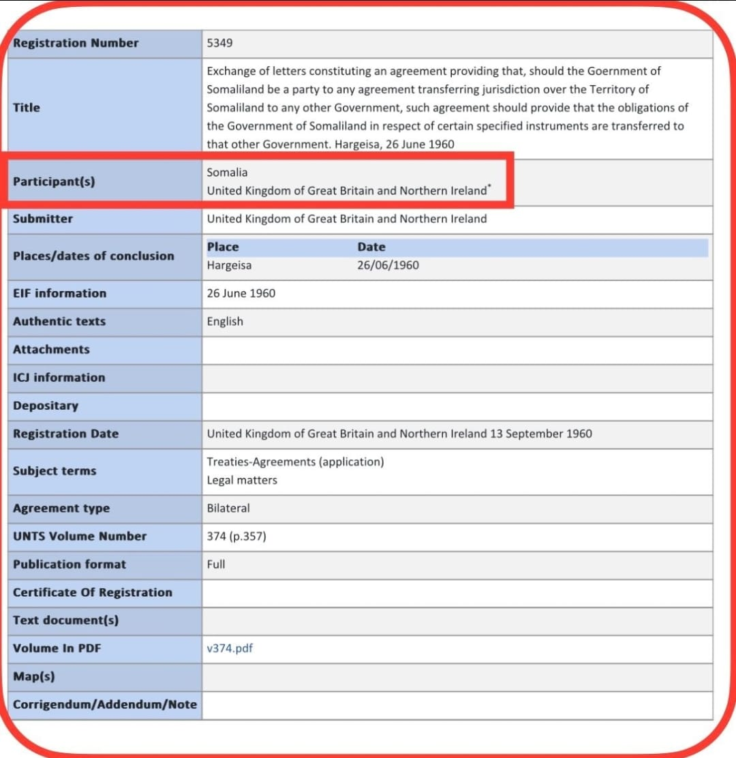

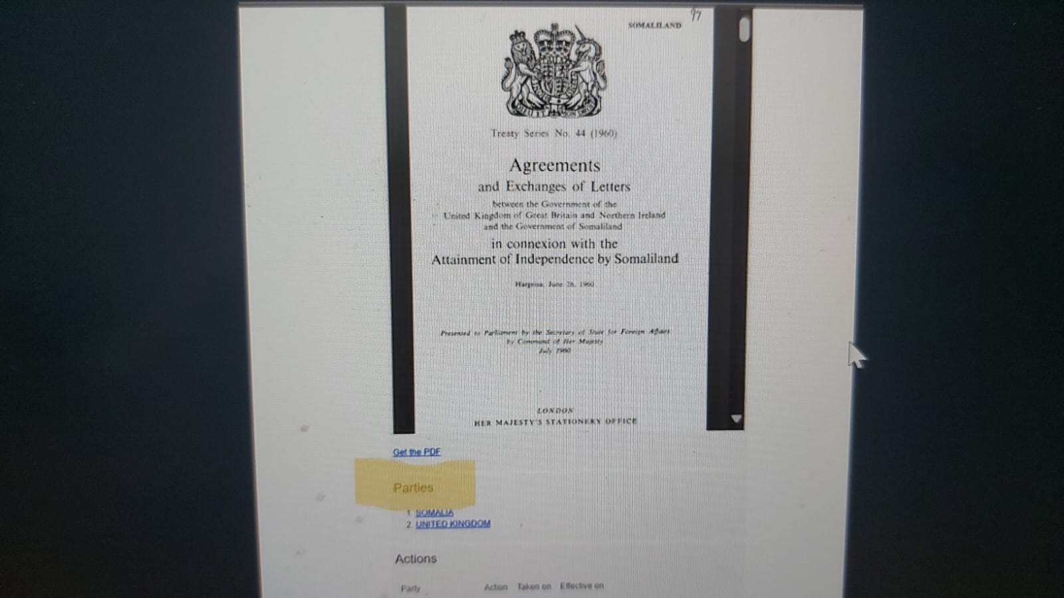

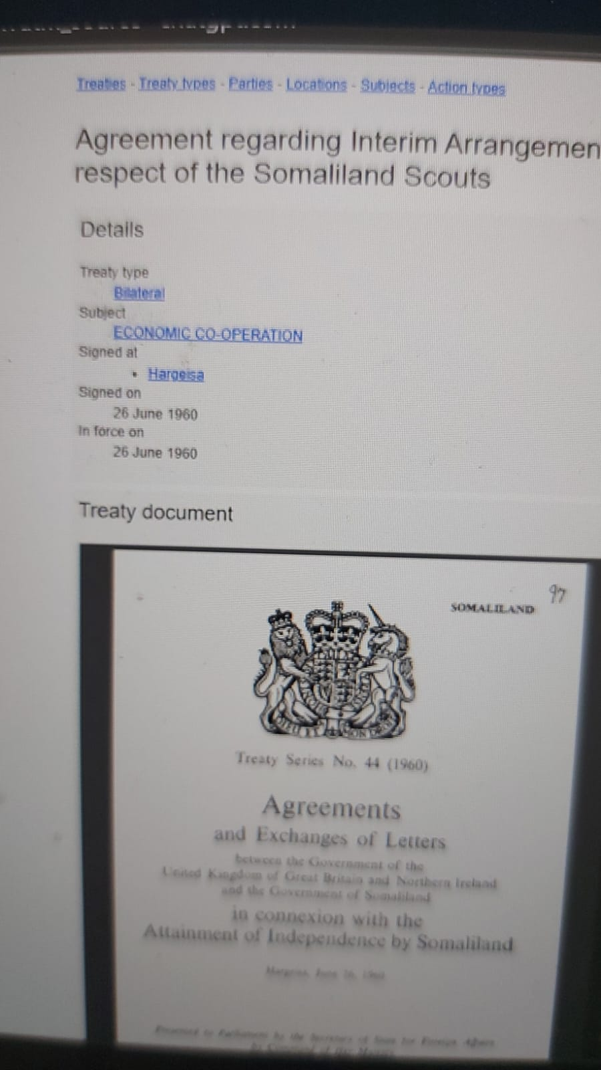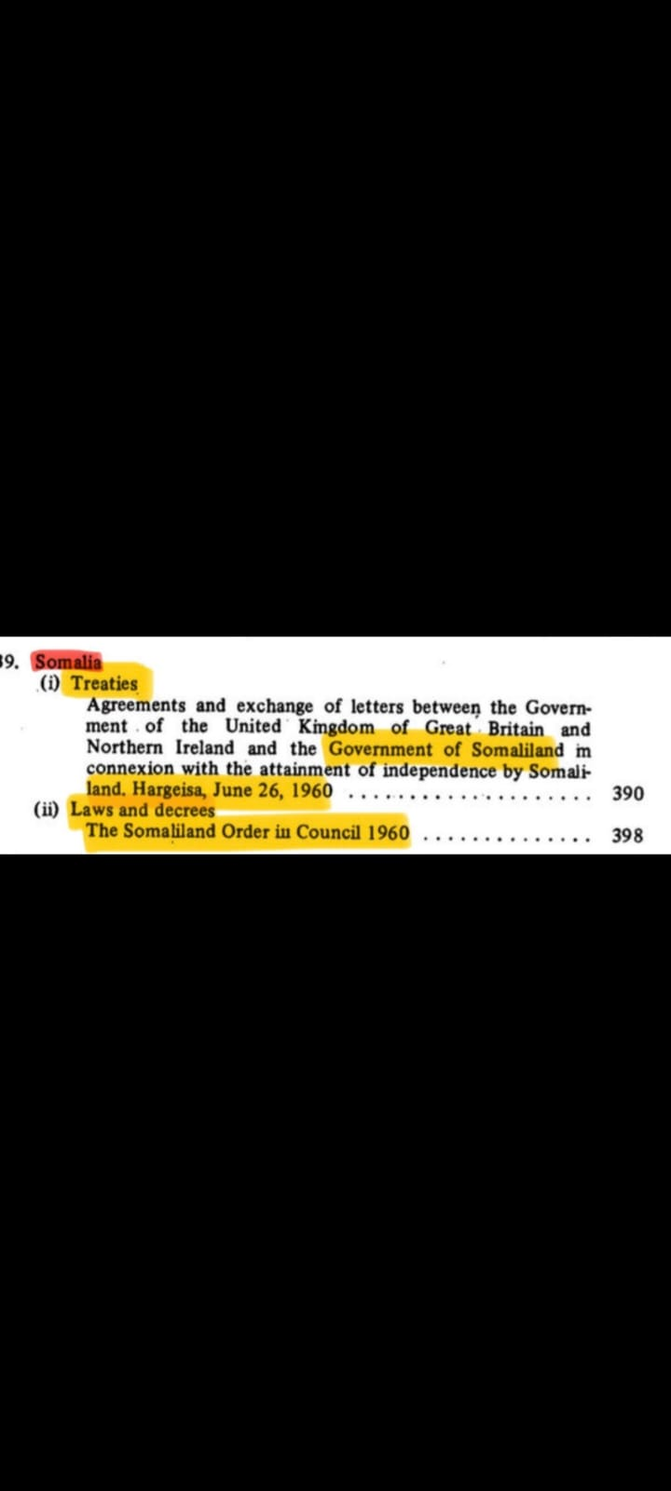
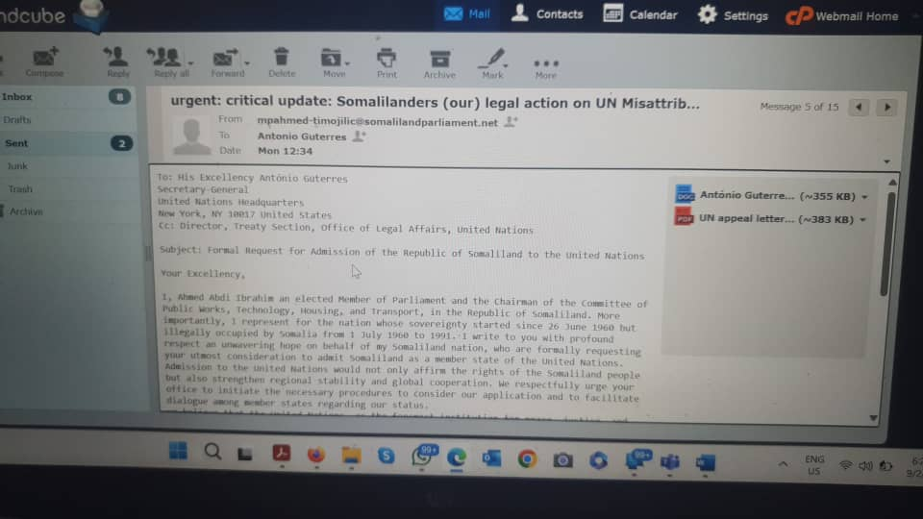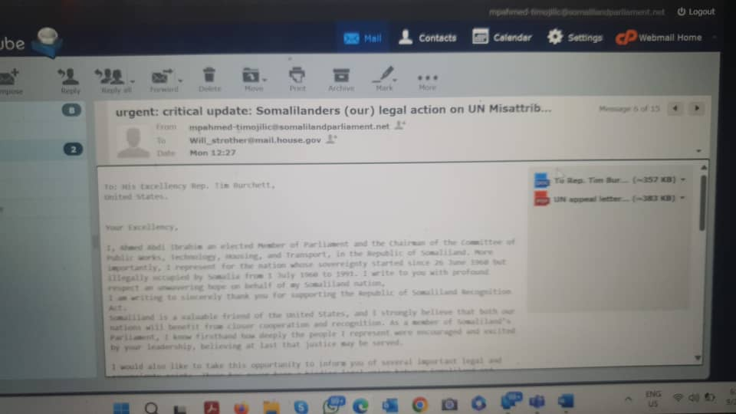

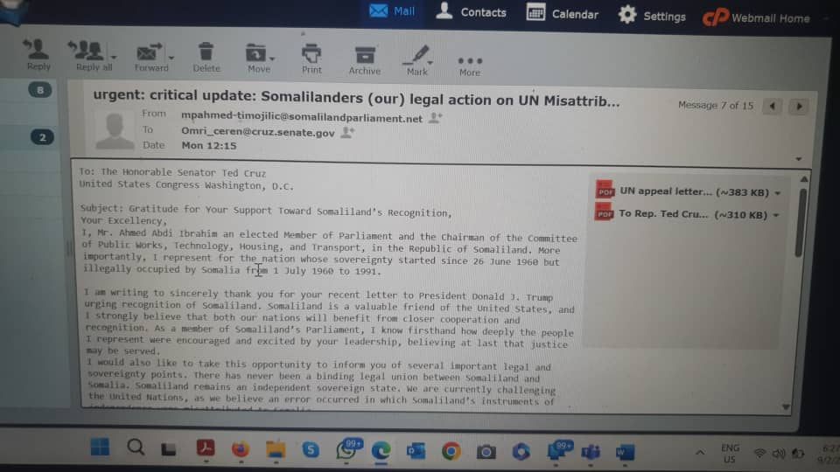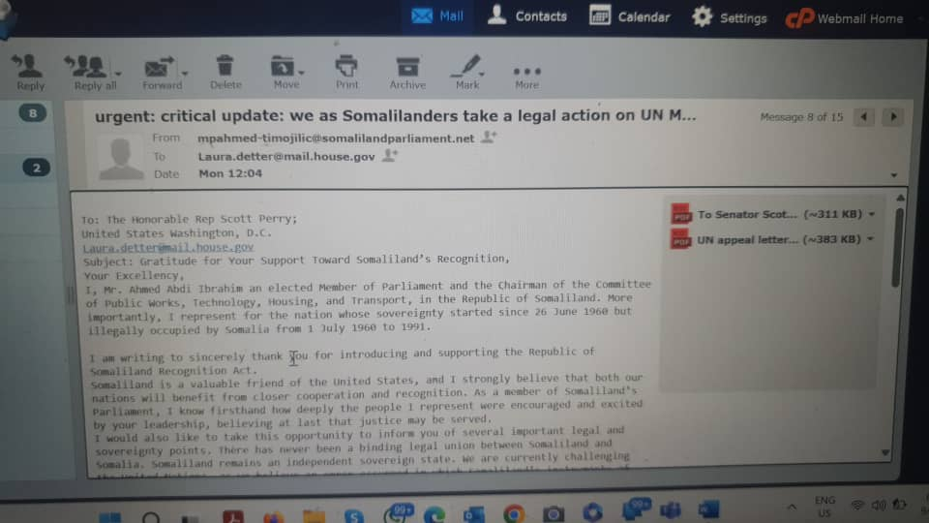

SR | Name of MP | email | Signiture
 | MPA Ahmed Abdi Ibrahim
 | MP
 | MP
 | MP
 | MP
 | MP
 | MP
 | MP
 | MP
 | MP
 | MP
 | MP
 | MP
 | MP
 | MP
 | MP
 | MP
 | MP
 | MP
 | MP
 | MP
 | MP
 | MP
 | MP
 | MP
 | MP
 | MP
 | MP

To: His Excellency António Guterres
Secretary-General
United Nations Headquarters
New York, NY 10017 United States
Cc: Director, Treaty Section, Office of Legal Affairs, United Nations
Subject: Formal Request for Admission of the Republic of Somaliland to the United Nations
Your Excellency,
I, Ahmed Abdi Ibrahim an elected Member of Parliament and the Chairman of the Committee of Public Works, Technology, Housing, and Transport, in the Republic of Somaliland. More importantly, I represent for the nation whose sovereignty started since 26 June 1960 but illegally occupied by Somalia from 1 July 1960 to 1991. I write to you with profound respect an unwavering hope on behalf of my Somaliland nation, who are formally requesting your utmost consideration to admit Somaliland as a member state of the United Nations.
Admission to the United Nations would not only affirm the rights of the Somaliland people but also strengthen regional stability and global cooperation. We respectfully urge your office to initiate the necessary procedures to consider our application and to facilitate dialogue among member states regarding our status.
we believe that the United Nations, as the foremost institution for peace, justice, and self-determination, has a moral and legal obligation to consider the aspirations of peoples who have demonstrated their readiness for responsible statehood. Please the attached documents:
UN appeal letter 2.5 Critical update: we, Somalilanders take a legal action on UN Misattribution
We remain committed to peaceful engagement, regional cooperation, and the values enshrined in the UN Charter. We stand ready to contribute meaningfully to the global community as a sovereign and responsible member.
With highest regards,

Waxanu Hambalyaynaynaa sanadguurada 80aad ee QM.

إلى: سعادة السيد أنطونيو غوتيريش

الأمين العام

مقر الأمم المتحدة

نيويورك، نيويورك ١٠٠١٧، الولايات المتحدة الأمريكية
نسخة إلى: مدير قسم المعاهدات، مكتب الشؤون القانونية، الأمم المتحدة
الموضوع: طلب رسمي لانضمام جمهورية أرض الصومال إلى الأمم المتحدة
الملحق القانوني المتكامل - أدلة على استمرارية دولة جمهورية أرض الصومال
الملحق الأول: أدلة على الشخصية القانونية الدولية واستمرارية دولة جمهورية أرض الصومال
١. الغرض والنطاق
يُقدَّم هذا الملحق دعماً لطلب جمهورية أرض الصومال النظر في انضمامها إلى الأمم المتحدة عملاً بالمادة ٤ من ميثاق الأمم المتحدة. يُوحّد هذا البيان ويُنسّق الأدلة القانونية والتاريخية والوثائقية التي تُثبت الشخصية القانونية الدولية لصوماليلاند، والتي اكتسبتها في 26 يونيو 1960، واستمراريتها دون انقطاع، على الرغم من الاتحاد غير المصادق عليه وغير القانوني الذي يُزعم أنه تم في 1 يوليو 1960.

2. هوية صوماليلاند واستمراريتها

جمهورية صوماليلاند الحالية هي الكيان القانوني نفسه الذي نال استقلاله عن المملكة المتحدة لبريطانيا العظمى وأيرلندا الشمالية في 26 يونيو 1960.
٢. هوية واستمرارية أرض الصومال
إن جمهورية أرض الصومال الحالية هي الكيان القانوني نفسه الذي نال استقلاله عن المملكة المتحدة لبريطانيا العظمى وأيرلندا الشمالية في ٢٦ يونيو ١٩٦٠. وقد استُخدم مصطلح "جمهورية" منذ عام ١٩٩١، بعد استعادة السيادة إثر طرد أرض الصومال لسلطة الاحتلال غير الشرعية للصومال. ولا يؤثر هذا التغيير في التسمية على استمرارية الشخصية القانونية للدولة.

لذا، فإن مطالبة أرض الصومال هي مطالبة باستمرارية الدولة واستعادة السيادة، وليست مطالبة بالانفصال.
3. أهلية إبرام المعاهدات والتسجيل لدى الأمم المتحدة (المادة 102)
تتجلى سيادة أرض الصومال وأهليتها لإبرام المعاهدات في عام 1960 من خلال الاتفاقيات الدولية المبرمة باسمها والمسجلة في سلسلة معاهدات الأمم المتحدة (UNTS) وفقًا للمادة 102 من ميثاق الأمم المتحدة. ويُعد هذا التسجيل بمثابة تأكيد مبدئي على أن أرض الصومال كانت تُعامل كشخصية خاضعة للقانون الدولي، قادرة على إبرام المعاهدات.

3.1 المعاهدات المسجلة في سلسلة معاهدات الأمم المتحدة
تم إبرام الصكوك التالية بين المملكة المتحدة وأرض الصومال، ودخلت حيز النفاذ في 26 يونيو 1960، وسُجلت لدى الأمم المتحدة في 13 سبتمبر 1960:

• رقم 5346 في سلسلة معاهدات الأمم المتحدة - اتفاقية مؤقتة لبعثة مساعدات من المملكة المتحدة (موقعة في هرجيسا، 26 يونيو 1960؛ دخلت حيز النفاذ بالتوقيع وفقًا للمادة الثامنة).

رقم معاهدات الأمم المتحدة 5346 - اتفاقية مؤقتة لبعثة مساعدات من المملكة المتحدة (موقعة في هرجيسا، 26 يونيو 1960؛ دخلت حيز النفاذ بالتوقيع وفقًا للمادة الثامنة). • اتفاقية الأمم المتحدة رقم 5347 - اتفاقية الموظفين العموميين (موقعة في هرجيسا، 26 يونيو 1960؛ دخلت حيز النفاذ بالتوقيع وفقًا للمادة السابعة).

اتفاقية الأمم المتحدة رقم 5348 - اتفاقية بشأن الترتيبات المؤقتة المتعلقة بكشافة أرض الصومال (موقعة في هرجيسا، 26 يونيو 1960؛ دخلت حيز النفاذ بالتوقيع وفقًا للمادة العاشرة).

اتفاقية الأمم المتحدة رقم 5349 - تبادل الرسائل المتعلقة بنقل الالتزامات في حالة نقل الاختصاص القضائي
(موقعة في هرجيسا، 26 يونيو 1960؛ دخلت حيز النفاذ بتبادل الرسائل).

• وثيقة الأمم المتحدة رقم 5350 - تبادل الرسائل بشأن استمرار توفر عملة مجلس النقد لشرق أفريقيا (موقعة في هرجيسا، 26 يونيو 1960).

تؤكد هذه التسجيلات أن أرض الصومال كانت تتمتع بالشخصية القانونية الدولية عند استقلالها.

4. غياب صك اتحاد صحيح
لا توجد معاهدة دولية قانونية تنازلت بموجبها أرض الصومال عن سيادتها أو أنهتها بعد 26 يونيو 1960. إن الاتحاد المزعوم في 1 يوليو 1960 لا يستوفي المتطلبات الأساسية لقانون المعاهدات للأسباب التالية:

• لم يُصدّق عليه المجلس التشريعي لأرض الصومال؛

• لم يُبرم كمعاهدة واحدة متناسقة بين دولتين ذواتي سيادة؛

• لم يُسجل لدى الأمم المتحدة بموجب المادة 102 من ميثاق الأمم المتحدة؛

• افتقر إلى الشرعية الدستورية داخل أرض الصومال.

وبناءً على ذلك، فإن الاتحاد المزعوم لا يُشكّل صكًا دوليًا مُلزمًا.

5. مبادئ القانون الدولي السارية
يستند الموقف القانوني لصوماليلاند إلى مبادئ راسخة، منها:

• حق تقرير المصير (ميثاق الأمم المتحدة، المادة 1(2))؛

• قبول الدول المُحبة للسلام (ميثاق الأمم المتحدة، المادة 4)؛

• مبدأ استمرارية الدولة، كما هو مُبيّن في الممارسة الدولية والفقه القانوني.

• معايير اتفاقية مونتيفيديو (1933)، والتي تستوفيها أرض الصومال بالكامل: أراضٍ محددة، وسكان دائمون، وحكومة فعّالة، والقدرة على إقامة علاقات مع دول أخرى.

6. أثر ذلك على نظر الأمم المتحدة
بما أن سيادة أرض الصومال قد أُرسيت بشكل قانوني عام 1960 ولم تُسقط قط بشكل قانوني، فإن الطلب الحالي المقدم إلى الأمم المتحدة يتعلق بالاعتراف بدولة قائمة وقبولها، وتصحيح خطأ تاريخي ومؤسسي في نسب السيادة.

7. الموقف القانوني الختامي
الصيغة المقترحة لسجلات الأمم المتحدة:

"جمهورية أرض الصومال هي الشخصية القانونية المستمرة لدولة أرض الصومال التي نالت استقلالها في 26 يونيو 1960، كما يتضح من المعاهدات المبرمة باسمها والمسجلة في سلسلة معاهدات الأمم المتحدة. لا يوجد أي صك دولي قانوني نُقلت بموجبه هذه السيادة أو أُسقطت."
مقدم نيابة عن حكومة وشعب جمهورية أرض الصومال.

